**ABSTRACT**

The advent of internet technology has enabled electronic procurement in industry which aids in the reduction of procurement costs. Among the technologies that have been praised by many stakeholders in reducing tendering cost, it is the arrival of electronic tendering (e-tendering). The aim of this research is to develop an e-tendering system for Telone Center for Learning. The study targeted procurement of college resources. The findings make an invaluable contribution to highlight the inefficiencies of traditional paper-based tendering system, barriers to the full implementation and the benefits of e-tendering. The recommendations include conducting awareness campaign of the benefits of e-tendering amongst built environment practitioners, highlighting the inefficiencies of paper-based tendering system and dealing with the barriers of e-tendering. There is also a need to formulate rules and regulations that accommodate e-tendering. In addition, promoting e-tendering system to ensure its acceptability among the stakeholders.

## 1.1 INTRODUCTION

Tendering, generally, is the process which is undertaken to obtain offers to create a contract between a client and a contractor (Tindsley & Stephenson, 2008). E-tendering is therefore defined as the process by which tender documentation, such as drawings, bills of quantities (BoQ) and specification are issued to suppliers of resources in an electronic format and via the internet. Therefore, the invitation to tender, tender award, contract administration and monitoring project performance will be all undertaken electronically online. Furthermore, tender queries, tender addendums, updates, evaluation of work for payment and notification of payments are all to be exchanged electronically on the internet via the system’s website and e-mail (Al-Lawati & Aibinu, 2008). E-tendering is the process of issuing electronic tender documentation to main contractors, sub-contractors and suppliers of college resources and receiving their responses electronically (CIOB, 2009).

## 1.1 Background Study

As we know in present system, procurement advertising is done through newspapers, which is causing problems like communication gap between companies and government authorities because of this problem competition is reducing, ultimately cost of project is increasing. There is no computerize system in the purchasing office so the user follows the old system to get the response of the requests. Think about it how much is difficult to fill all data in paper during in digital technology and difficult to know how much time is needed to get ordered materials from different customers held in the company.

Here are the problems on the existing system

* It is more time consuming.
* It includes wastage of man power
* It leads to tender ring
* It includes wastage of money

So, in order to overcome all these limitations and to meet all their requirements the current process is replaced with this application.

## 1.2 Problem Statement

The current system needs large storage capacities, like storing rooms and archives are required to store tenders and projects documents and drawings and there is lack of security of stored data in papers; there is also time wastage and cost in exchanging information and tender documents; and there is labor intensive tasks required to issue and respond to tenders; intensive administrative tasks, such as, printing, collating, binding and distributing of tender documents to all interested contractors. In addition, paper-based method of tendering has inherent inefficiencies in many forms such as handling errors, estimating process errors, and finally errors that arise during evaluation but all these errors can be eradicated/minimized with the use of e-tendering.

## 1.3 Aim

The main aim of the project is to develop a web based e-tender system for Telone that will allow online bidding participation.

## 1. 4 Objectives

* To allow online bidding participation
* To allow online selection of the best bidder
* To notify bidders about tenders

## 1.5 Scope of study

The scope of the project will cover the system functionalities, technologies used, the targeted users, system deployment and methodology. As a whole the system is focused to work with Electronic Tendering system.

## 1.6 Justification

The process tries to eliminate paper while shortening the time taken to submit and respond to queries. Clarifications should be issued electronically and distributed automatically to all interested parties, thus reducing the risk of errors and increasing visibility of responses to all interested parties. This increases the accuracy of tenders while reducing the cost of managing the tender process (CITAX, 2008; RICS, 2005; Brooks, 2008).The benefits of e-tendering include: simplifying the process; reduced tendering period; fast and accurate pre-qualification and evaluation, avoiding the need for double or triple entry of the same information, and the reduction in labor-intensive tasks of receipt, recording and distribution of tender documents. There is increased integrity and transparency in the tendering process, a reasonably high return on invested funds on such technology improved quality of tender specification and supplier response and provision of quality management information (Brooks, 2008; Tindsley & Stephenson, 2008; Lou & Ashalwi 2009; Oyediran & Akintola, 2011; RICS, 2005).

It is interesting to further note that e-tendering increases the level of security and authentication of the tender process. The findings are in sharp contrast to the industry continued concern that it exposes sealed bids to possible hacking which defeats the principle of sealed bids. Most e-tendering software solutions provide additional support such as archiving, document management, early warning of opportunities to suppliers, and maintenance of approved and/or potential supplier lists (Local e-gov, 2011).

## 1.7 Research Hypothesis

A number of solutions can be employed to the current system as follows:

H 0: Developing a E-tendering system

Of the above alternatives, E-tendering system is the best more modern alternate.

If partially automated, the system will be flexibly able to retrieve, update information and status quickly, when required without taking much time. Users will be able to view tenders, their bidding status and get tender notifications directly to their emails from any angle of the country.

## 1.8 Research Questions

* How can someone bid for a tender?
* How is the best bidder selected?
* How are the bidders notified about tenders?

## 1.8 Limitations and Delimitations

The benefits of using e-tendering are primarily perception based and not quantifiable (Westcott & Mayer, 2002; Egbu, Gaskell & Howes, 2001; Yang, Ahuja & Shankar, 2007). Deloitte (2004) reports that one of the key challenges to deriving benefits from e-tendering as: authorities need to invest money and time to both identify their opportunity from e-tendering and to deliver the expected benefits; the presence of internal resistance to adopting a corporate, standardized approach to tendering; change management is critical to securing buy-in; supplier concerns over the robustness of the technology and practical issues such as file sizes; a supplier education process is essential; there is choice as to the technology solution — package versus bespoke; in-house versus hosted.

The study is going to be done at Telone Center for Learning due to resources to travel to the head office. It is for the college where the student is doing his studies.­­

# **CHAPTER 2: Literature Review**

## **Introduction**

A literature review surveys books, scholarly articles, and any other sources relevant to a particular issue, area of research, or theory, and by so doing, provides a description, summary, and critical evaluation of these works in relation to the research problem being investigated. Literature reviews are designed to provide an overview of sources you have explored while researching a particular topic and to demonstrate to your readers how your research fits within a larger field of study. [Fink, Arlene. *Conducting Research Literature Reviews: From the Internet to Paper*. Fourth edition. Thousand Oaks, CA: SAGE, 2014.]

A literature review is an objective, critical summary of published research literature relevant to a topic under consideration for research. Its purpose is to create familiarity with current thinking and research on a particular topic, and may justify future research into a previously overlooked or understudied area. [Thompson Rivers University, Pamela Fry, 2013]

## **What is E-tendering**

E-Tendering, generally, is the process which is undertaken to obtain offers to create a contract between a client and a contractor (Tindsley & Stephenson, 2008). E-tendering is therefore defined as the process by which tender documentation, such as drawings, bills of quantities (BoQ) and specification are issued to organisations which needs supply of resources or services in an electronic format and via the internet. Therefore, the invitation to tender, tender award, contract administration and monitoring project performance will be all undertaken electronically online. Furthermore, tender queries, tender addendums, updates, evaluation of work for payment and notification of payments are all to be exchanged electronically on the internet via the system’s website and e-mail (Al-Lawati & Aibinu, 2008).

It can also be defined as the process of issuing electronic tender documentation to main contractors, sub-contractors and industry suppliers and receiving their responses electronically (CIOB, 2009).

## 2.1 How can someone apply for a tender?

## Traditional Paper-Based Tendering Method in construction industry

The traditional tender process involves the professional quantity surveyor (PQS) gathering the documentation together. This includes: photocopying/printing; assembling it into packages; binding, and dispatching to each of the prospective bidders for the tender. The dispatching thereof may be paid for by the bidder or by the PQS and normally involves the documentation being delivered by courier (CITAX, 2008). The process which involves the PQS in preparing tender documentation includes: the BoQs that lists all of the items that should be priced in each bid; drawings that are relevant to the tender, and any other relevant information (CITAX, 2008).

### **Constraints of the Paper-Based Method of Tendering**

Many researchers have highlighted inefficiencies that are prevalent when using this method of tendering that can be eliminated when using e-tendering. These disadvantages include: large storage capacities, such as, storing rooms and archives are required to store tenders and projects documents and drawings; lack of security of stored data in papers; time wastage and cost in exchanging information and tender documents; labour intensive tasks required to issue and respond to tenders; intensive administrative tasks, such as, printing, collating, binding and distributing of tender documents to all interested contractors (Al Dhuhli, 2002). In addition, CITAX (2008) admits that the paper-based method of tendering has inherent inefficiencies in many forms such as handling errors, estimating process errors, and finally errors that arise during evaluation. CITAX (2008) further posits that all these errors can be eradicated/minimized if e-tendering can be introduced in an organization.

### **Procurement System in other Countries**

In the tender handling system, all the tenders are processed through documents. It is a manual system. This system is called open document system. In this first of all tender notices are given in newspapers with the details about work. Then the contractors read the tender notification and buy the tender schedule by paying the tender fee if they are interested to do that particular work. In that schedule all the details of the work are available to the contractors. Then the contractors send submission details which include quotation of the tender before tender submission closing date through post or by hand. On evaluation date the department people evaluate all the tender details submitted by the contractors. The department people give that work to the contractor who is eligible and quoted for fewer amounts.

**Problems with this System:**

* It is more time consuming.
* It includes wastage of man power
* It leads to tender ring
* It includes wastage of money

So in order to overcome all these limitations and to meet all their requirements the current process is replaced with this web application.

### Current System description

When the Trading House want to buy goods or materials, first they organize a committee that identifies the type of goods that should be bought, after the identification they propose the goods to the highest body in the organization; then the highest body of the organization assess the goods that provided by the auction committee and then it decides whether they should be buy or not. The existing system has procedures that must be followed according to the law and regulations of tender. After the approval made by the highest body, the company brings it to the media, and the committee decides the place where procure should be held and the starting and closing date of auction.

* During the procurement planning process and the preparation of bidding documents, the procurement shall ensure that there is sufficient budget allocation.

**Preparation of bidding documents**

* The Procurement Unit prepares the bidding documents and incorporates the technical specifications based on the standard bidding documents. The bidding document is prepared based on the approved annual procurement plan which provides important details like quantities, cost estimates, method of procurement etc. Once the bidding document is ready it must be given to the Tender Committee which will review and provide comments. The bidding document is then finalized. In accordance with the procurement law, the bidding document should provide the following information:

1. The specific requirements relating to the goods, works or services being procured and the time limit for delivery or completion;
2. The general and specific conditions governing the contract, if the performance security is provided;
3. The tender number assigned to the procurement proceedings by the procuring entity;
4. Instructions for the preparation and submission of Bidders including:

* The bid form;
* The number of copies to be submitted with the original bid;
* Any bid security required, the form and amount of such security;
* Any proof evidencing the bidder’s qualifications.
* A statement of where and when tenders shall be submitted,
* A statement of where and when the tenders shall be opened;
* A statement of the period during which tenders shall remain valid;
* The procedures and criteria for bid evaluation and comparison;
* A statement that the procuring entity may cancel the bids at any time before the signing of the contract;
* Anything else as may be provided by the bidding document in accordance with this Law or public procurement regulations.

After the house announces the venue and the items for auctions to the general public through electronic or print media; The sellers who wish to take part in the auction should first take the document (the form that contains the list of materials which are proposed to be bought or wanted documents and other documents with a blank space that bidders will fill the price they wish) and then arrive at the venue of the auction on the given date and time with the necessary document. This method restricts most of the interested bidders out of the city or region to decline their offer or interest as they can’t be available on the day of auction. Another flaw of this method is the piles of paper work that has to be maintained then keep it save for the future. They have to keep track of the bidders and the sellers until their final settlement. Bidders submit bids that they want with in post which is sealed by wax and put it in an auction box. This process requires physical presence of the bidder himself/herself or by their agents. When the bidding time expires the auction process will be closed. After the closing date of the process then the Trading house collects these bids from the sellers and evaluate these bids. Finally, the auction committee decide the winner, bidder who bids lowest will be selected. Then company pays the required amount of money for the seller and in turn the winner gives the material. The buyers and branches, their notices and documents, contractor’s records and bid details are managed manually. No online registration and subscription provided.

### **Bidding Process:**

* The bidding process which involves both the technical bid and the financial bid is not automated. Bidders send the necessary documents like their tax and certificate, technical resources data and their quotations through post.
* In the bidding process, technical bid is the first stage if the materials need specification wherein the bidders have to give the proof of his solvency and the data about his financial position. Then he is required to give the details of the technical resources available with him. Both the technical bid and the price bid are kept in two separate covers which are again kept in one main cover. Only those bidders’ price bid is opened whose financial records and technical bid are satisfactory. Earned Money Deposit of those bidders who are not qualified at the technical bid stage may be refunded or returned, in form of CPO.
* After proper evaluation, the final bid is selected and the bidder whose bid is selected will have to pay some amount as a security deposit. This amount will be adjusted later on.

## **Problem of Existing system**

The problem with public auction is that the participation of the general public is very limited. This public auction is managed manually and involves lot of paper work. Another headache of the current system is to track each bidding process and to make it finish in financial settlement.

In present, there is no any process online for issue a new bidder. But all process work offline on paperwork. If any new buying is issue then organization gives an advertisement in TV, newspaper or any other resources. Newspaper contains only few details of materials, if any more details are required then suppler physically visit the organization. Manual procurement transactions can take up to 20-30 days to process, including all the time spent exchanging paperwork and contacting suppliers etc. An integrated e-Procurement solution can be used to simplify the procurement process.

### The existing System:

❖ No Automated Bidding Process:

The bidding process is completely manual and so very time consuming. There is no provision for online bidding.

❖ Security: The manual process is not very secure. In the new system, the passwords are generated so only the members know their passwords.

❖ Not as Accurate and Fast: Retrieving information is slower as everything is managed manually. Since, everything is managed manually; there might be a lack of accuracy.

❖ No Searching Facility: There are no searching facilities for bidders such as quick search mechanism in the existing system.

❖ It consume more personal power and material wastage like paper, pink related to printing documents for the sake of procurement guideline for employment.

❖ The existing system has a problem of keeping the records separately because of using a file-based system.

❖ Users are using Word or Excel to record companies’ names and personal details, writing one record many times in different sheets which leads to inconsistency of data. Consequently, users are facing the problem of getting reports on time because of searching the information related to one tender in different files.

❖ The existing system has many problems associated with it, for instance: it wastes time for recording the process of tender information.

❖ In the existing system, the process of evaluating tenders takes a lot of time to do analysis and to compare documents as they (users) write down and also remember they have to search for the documents they want manually.

❖ It is hard to get reports on time because they have to write manually. In other words, each record they keep is not in the format of reports, and at the time of issuing the report, they have to type it manually.

❖ Bidders who need to sell the things, he attends the place of bidding.

❖ It covers only limited Area, Bidders far from the organization will not participate.

❖ Limited Bidders and Sellers which leads to poor quality supply of goods

**Summary**

The preceding sections reviewed a number of systems on the bidding and selection of best bidders to supply services or resources of companies of various countries. However, because of some specific constraints that characterize each of these companies, the models presented in those studies are not readily applicable to procurement of materials at Telone Center for learning in Zimbabwe.

# Chapter 3

# **Methodology**

An object-oriented analysis and design approach is preferred to design the e-Tendering system. In accordance with this selection and due to the requirement of platform-independency, PHP is chosen as the development language. For database management system, MySQL database is used.

UML modeling notation is utilized during analysis and design phases. Use-case diagrams, activity diagrams and class diagrams are used to model the e-Tendering system.

In requirements specification phase, use-cases are utilized to define the external behavioral aspects of the e-Tendering system.

## Following the implementation of the e-Tendering system, in order to evaluate the effectiveness, applicability, and usability of the system, trials have been performed involving real users (4 vendors and 2 public institutions). Recommendations and evaluations of participants, obtained by the questionnaire, are utilized as the deciding factors in the assessment of effectiveness and usability of the system. At the end of the study, based on these factors, further improvements to the system developed are proposed.

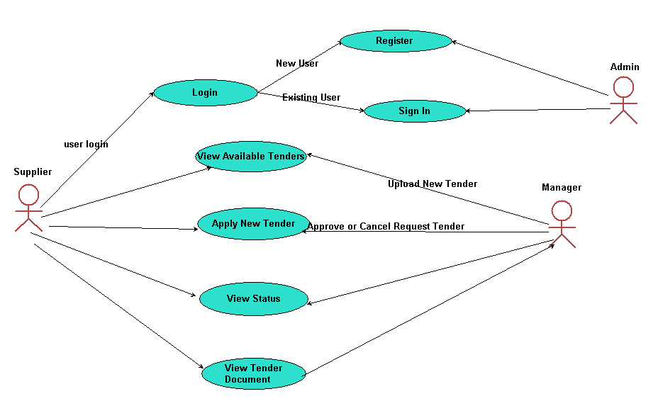



Sequence diagram,



## class diagrams



# **CHAPTER 4**

# **4.0 DATA PRESENTATION AND ANALYSIS**

Listed Tenders on Bid

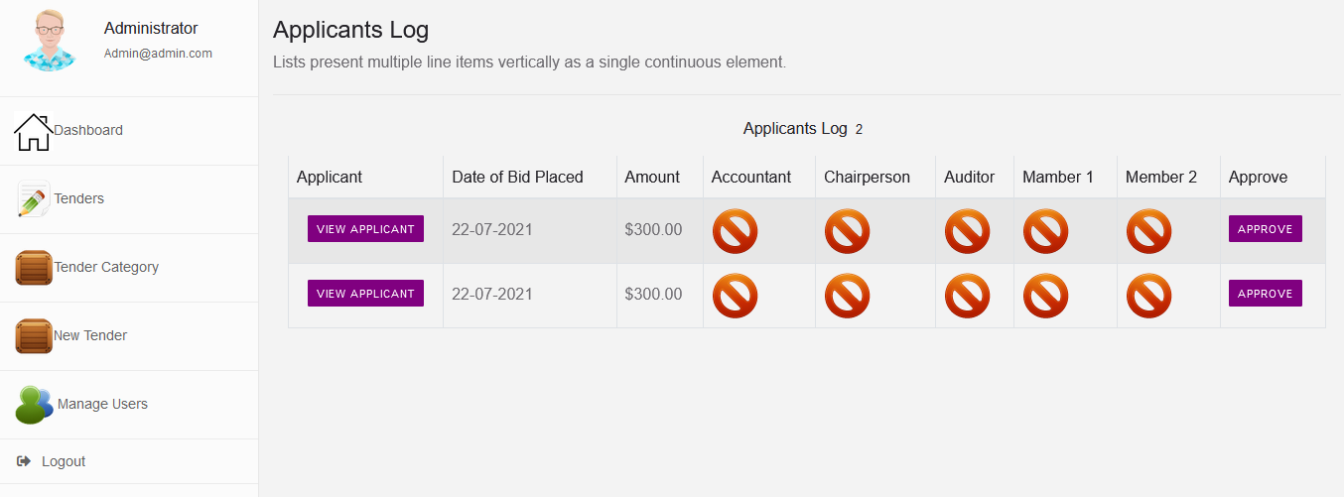

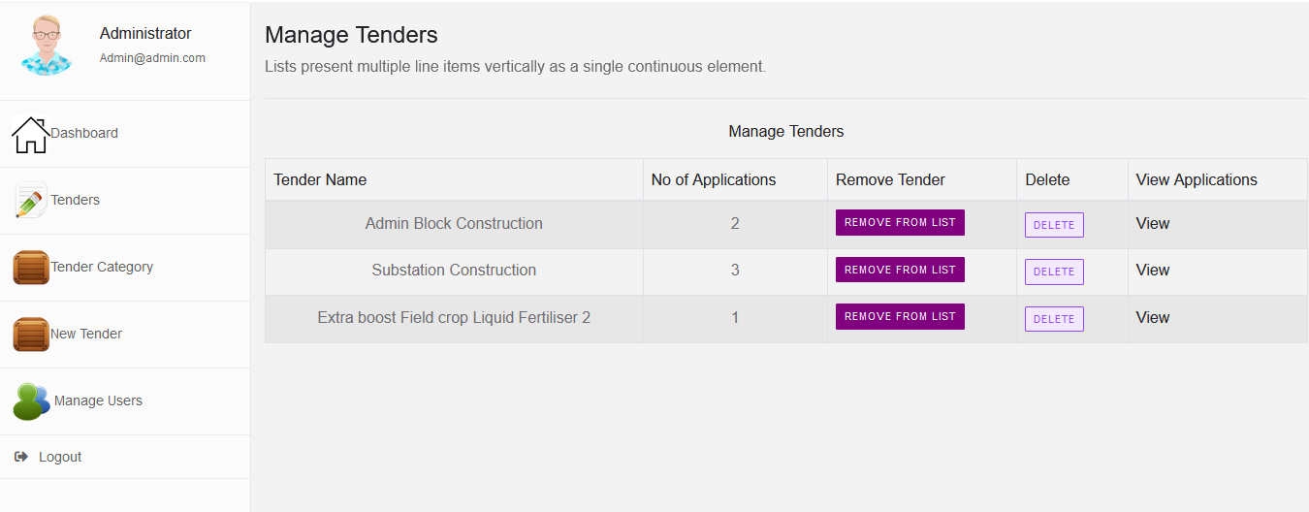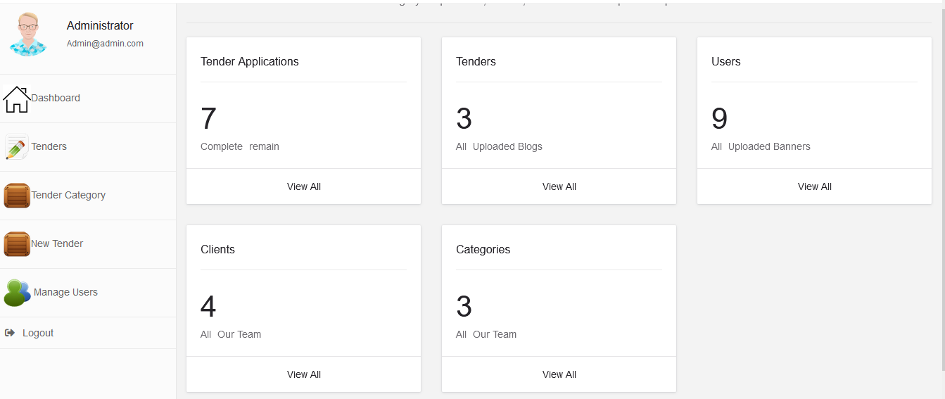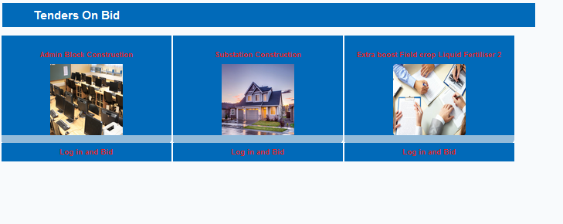

Tenders table in the database

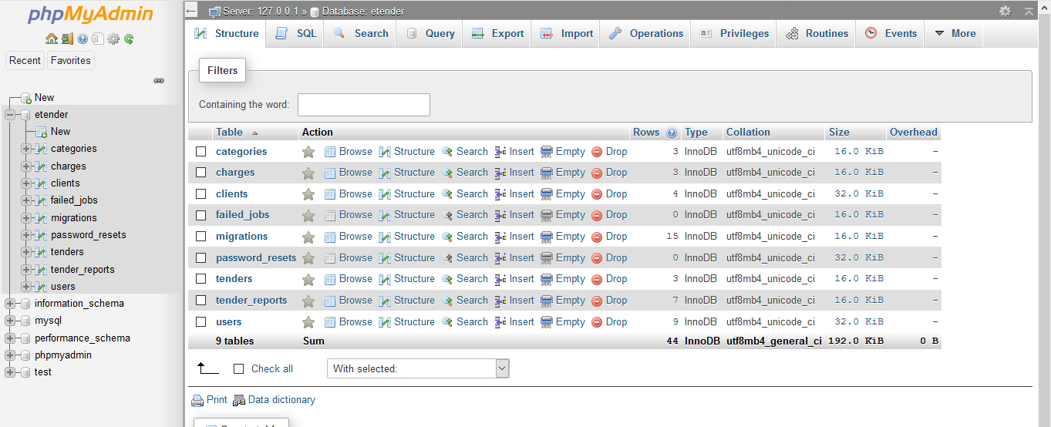

## 

**The existing System:**

❖ No Automated Bidding Process: The bidding process is completely manual and so very time consuming. There is no provision for online bidding.

❖ Security: The manual process is not very secure. In the new system, the passwords are generated so only the members know their passwords.

❖ Not as Accurate and Fast: Retrieving information is slower as everything is managed manually. Since, everything is managed manually; there might be a lack of accuracy.

❖ No Searching Facility: There are no searching facilities for bidders such as quick search mechanism in the existing system.

❖ It consume more personal power and material wastage like paper, pink related to printing documents for the sake of procurement guideline for employment.

❖ The existing system has a problem of keeping the records separately because of using a file-based system.

❖ Users are using Word or Excel to record companies’ names and personal details, writing one record many times in different sheets which leads to inconsistency of data. Consequently, users are facing the problem of getting reports on time because of searching the information related to one tender in different files.

❖ The existing system has many problems associated with it, for instance: it wastes time for recording the process of tender information.

❖ In the existing system, the process of evaluating tenders takes a lot of time to do analysis and to compare documents as they (users) write down and also remember they have to search for the documents they want manually.

❖ It is hard to get reports on time because they have to write manually. In other words, each record they keep is not in the format of reports, and at the time of issuing the report, they have to type it manually.

❖ Bidders who need to sell the things, he attends the place of bidding.

❖ It covers only limited Area, Bidders far from the organization will not participate.

❖ Limited Bidders and Sellers.

## STRENGTHS OF THE CURRENT SYSTEM

* Physical attendance of the bidders avoids ghost bidders
* No technical labour is required to use the paper based system

## EVALUATION OF ALTERNATIVES

The general objective is to automate the procurement system

The main objective of this project is as follows

1. This portal will gives procuring /purchasing of product online.

2. Implementing online creation, editing of bids.

3. Implementing viewing, applying for bids by Sellers.

4. Design a database which is able to keep every transaction related to tender process.

5. The user will be able to generate a report they need on time because every record will be saved in database.

6. Implement the level of security so that every user will be able to access the information according to their role in the system.

## 4.2 DATA ANALYSIS-DFDs,



# **CHAPTER 5**

# **5.0 RESULTS AND DISCUSSIONS**

Tender notifications (sometimes called tender alerts), will provide the client with given tender information that they desire. This is often delivered in the form of an email notification, saving the client visiting multiple websites to check for updates on potential clients. Most repacks provide both private and public sector tender opportunities. The idea is that tendering system deliver tender opportunities to the company; dramatically reducing the amount of time spent looking for these tenders. An internet-based process wherein the complete tendering process; from advertising to receiving and submitting tender-related information are one online. This enables firms to be more efficient as paper-based transactions are reduced or eliminated, facilitating for a speedier exchange of information. In the existing system all the tenders are processed manually through documents. This tendering system is called open documentation system. In this the department people publish the tender notice in newspapers, then the contractors buy the tender forms from the specified department by paying tender fee. If the contractors are interested to do the particular work, they have to submit quotation along with their eligibility details by post or by hand in sealed covers. Finally, the department people open the sealed covers on tender evaluation date and evaluate the submitted quotations in presence of all contractors. Due to this, there is wastage of manpower, money, and time. It tends to form tender ring. To avoid all the above pitfalls, all the tenders processed through online. This system saves money, manpower, time and it reduces the chances for tendering. It provides security compared to existing system. E-tendering system is relatively simple technical solution based around e-mail and electronic document management. It involves uploading tender documents on to the website with secure login, authentication and viewing rules. Tools available in the current market offer varying levels of sophistication.

A simple e-tendering solution may be a space on a web server where electronic documents are posted with basic viewing rules. Such solutions can offer valuable improvements to paper-based tendering. It also includes more complex collaboration functionality, allowing numbers of users in different locations to view and edit electronic documents. They may also include e-mail trigger process control which alerts users for example of a colleague having made changes to a collaborative tender, or a supplier having posted a tender. The most sophisticated systems may use evaluation functionality to streamline the tender process from start to finish, so that initial tender documents are very specific and require responses from vendors to be in a particular format. These tools then enable evaluation on strict criteria which can be completely automated.

❖ **Security:** The system is designed in a way that it prompts the user with password and user email. This provides security in such a way that unauthorized users can not have access to the system’s resources. Moreover, the system can reject invalid user inputs to ensure the system’s robustness for all interacting users.

❖ **Maintainability:** the system is extensible enough to incorporate functionalities and easy modification.

❖ **User Interface:** Our system provides user friendly and self-explanatory graphical user interface that eases the interaction of the user with the system, it also has helping contents that for how to use the system

❖ **Robustness:** Since error handling and extreme condition is one of the nonfunctional requirements of the system to handle wrong user action. Invalid user input or any incomplete information that may encounter errors, the system withstands invalid input so that it functions under those condition if the users type invalid text query, also it generates a means to kindly handle the situation to formulate the query again.

❖ **Reliability**: The system is reliable and consistent so that it provides the correct result in all circumstances unless an error is encountered. If an error occurs the system will trap the error in the input and notify the user to take appropriate corrections.

❖ **Availability**: The system is web based or online system so it will be accessible 24 hours per day and 7 days per week and also the system accessible from any system that can have internet access (like computers, smartphones, tablets) and will be accessible anytime a user would want to use the system.

❖ **Easy to use:** This system has a well-defined and easily understood interface.

❖ **Data integrity:** The system to maintains and assures the accuracy and consistency of data over its entire life-cycle, and is a critical aspect to the design, implementation and usage of system which stores, processes or retrieves data.

# **CHAPTER 6**

# **6.0 CONCLUSION AND RECOMMENDATIONS**

In this chapter, the findings of the study are discussed and recommendations for further studies are indicated.

**6.1. Conclusion**

Electronic Tendering System, as one of the e-Government initiative, is perceived to be an alternative that leads to better and more effective public procurement management by overcoming many traditional paper-based problems. e-tendering process brings essential benefits for both the government and the private sector. It provides an open purchasing environment that facilitates interoperability between them in order to conduct public procurement activities. However, there are some drawbacks of these initiatives such as lack of standard common definitions for goods and services, lack of integration with other e-Government applications and lack of reliable identification of vendors and public institutions. In this respect, this study may contribute to e-Procurement studies in Zimbabwe by means of developing a web-based prototype system that support the tendering activities of Telone.

In this study, detailed description of electronic public procurement process regarding e-Tendering, e-Purchasing and auditing components has been provided. Among these components only the e-Tendering component has been implemented. The resulting system is a web-based Tendering system designed to connect public institutions as 103 buyers and businesses as sellers. Through this system it is aimed to support two tendering procedures, namely open procedure and restricted procedure, which are regulated by law.

Among the most important functionalities of the system are providing immediate responses through e-mail communication, verification of vendors against.

In addition, this system offers the potential for significant savings such as decrease in costs associated with publishing and getting information, increase in competition, and improvements in transparency in public administration and enhancements in the overall quality of public procurement management throughout savings in terms of cost and time.

However, electronic transformation of public procurement process brings not only lots of opportunities but also some challenges facing both public and private sector. The central issue is to resolve the issues of interoperability and to seek a way to optimize existing public procurement process. However, these issues have not been adequately recognized by the e-Procurement implementing institutions.

Lack of standardization is a major obstacle to e-tendering initiative. It is required to develop common standards for classification of goods and services, web-based tendering and verification of vendors and public institutions. In addition, managing e- tendering demands more comprehensive skills because it is linked to accounting, budgeting, inventory management and public investments. Therefore, standardization and interoperability remains important as better and more effective e- tendering solutions are pursued.

## **Recommendations For Future Work**

One of the recommendations for the future work is to improve e-tendering according to the recommendations given by the participants in the case study. In this respect, the following issues might be considered:

• In ZImbabwe, there is no synchronous e-tendering. The further research that examines such environments and designs a tool addressing e-Tendering functionality may be useful.

• The creation of XML schemas and making integration to other e-Government services will be a good idea.

Also, the development of standard common product classification and definition schema will contribute to the existing process. In the e-tendering, a simple product classification code is defined and used. Therefore, it is easy to integrate a newly developed and more comprehensive product classification standard to the system.

The other alternative is to further investigate the effectiveness of e-tendering with more participants in order to make statistical analysis of the success factors. Moreover, it can be a good idea to examine the economic and social benefits of e- Tendering process comparing existing and electronic form of it and then to find out the impact of e- Tendering on the success of public IT projects.

# **10. APPENDICES**

## I: INTERVIEW GUIDE FOR E- TENDERING

**Date:**

**Name of Interviewee:**

**Organization of the Interviewee:**

INTRODUCTION

I am working on e-tendering. In this context, I have prepared a web-based public e-tendering system. In this interview, I want to get your opinions about the implementation of e-tendering system that you have been involved in. I am especially interested in the most challenging aspects of the system, strengths and weaknesses of the system, any problems you have faced, and recommendations about the functionality.

Before beginning, I want to make clear some important issues. I assure you that all your comments will remain confidential. I will be preparing a report that will contain all comments without any reference to individuals.

Please feel free, if you need to get information and ask questions.

QUESTIONS

* How do participants perceive the potential effectiveness of e-tendering system?
* What are the strengths and weaknesses of the e-tendering system?
* Which parts do participants want to be implemented differently?
* How do participants perceive the difficulties they face in using the e-tendering system?

(Probe to get any suggestions on how to minimize these problems)

* How can e-tendering system be improved to achieve more efficiency and effectiveness?